Home page

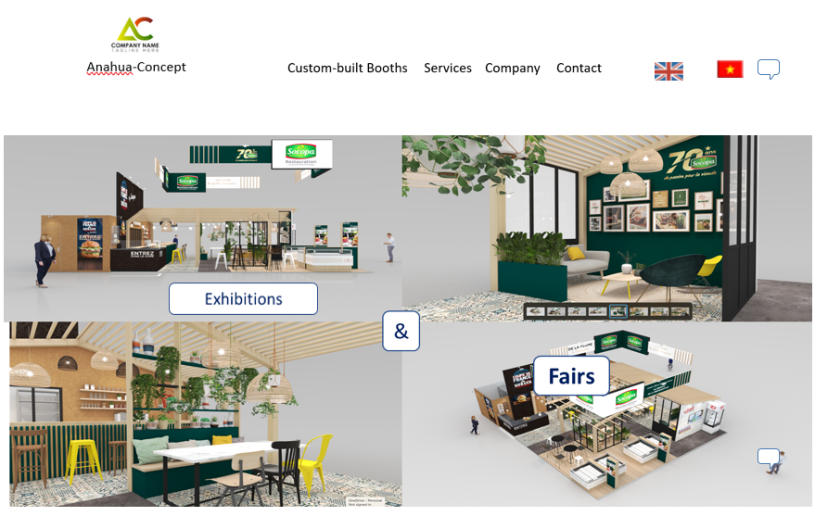

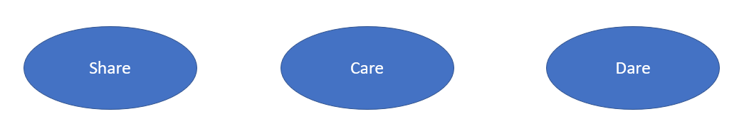

At Anahua-Concept, we don't just build exhibitions and fair booths; we create immersive experiences that share your brand story with the world. We believe in the power of every detail, carefully crafted with a blend of creativity and precision. We manage every stage of your booth development, from the initial concept to the final installation.

**Share** Your Vision: We collaborate with you to understand your unique vision, ensuring that every booth reflects the essence of your brand.

**Care** in Craftsmanship: With meticulous attention to detail, we care about delivering booths of the highest quality. Your success is our priority, and we take pride in the craftsmanship that goes into each project. We take care of the entire booth creation process from conception to completion.

**Dare** to Stand Out: In a world of ordinary, dare to be extraordinary. Our stands are designed to make a bold statement, daring your competitors to keep up.

Ready to transform your vision into a captivating reality? Contact us and let's dare to innovate your exhibition presence!

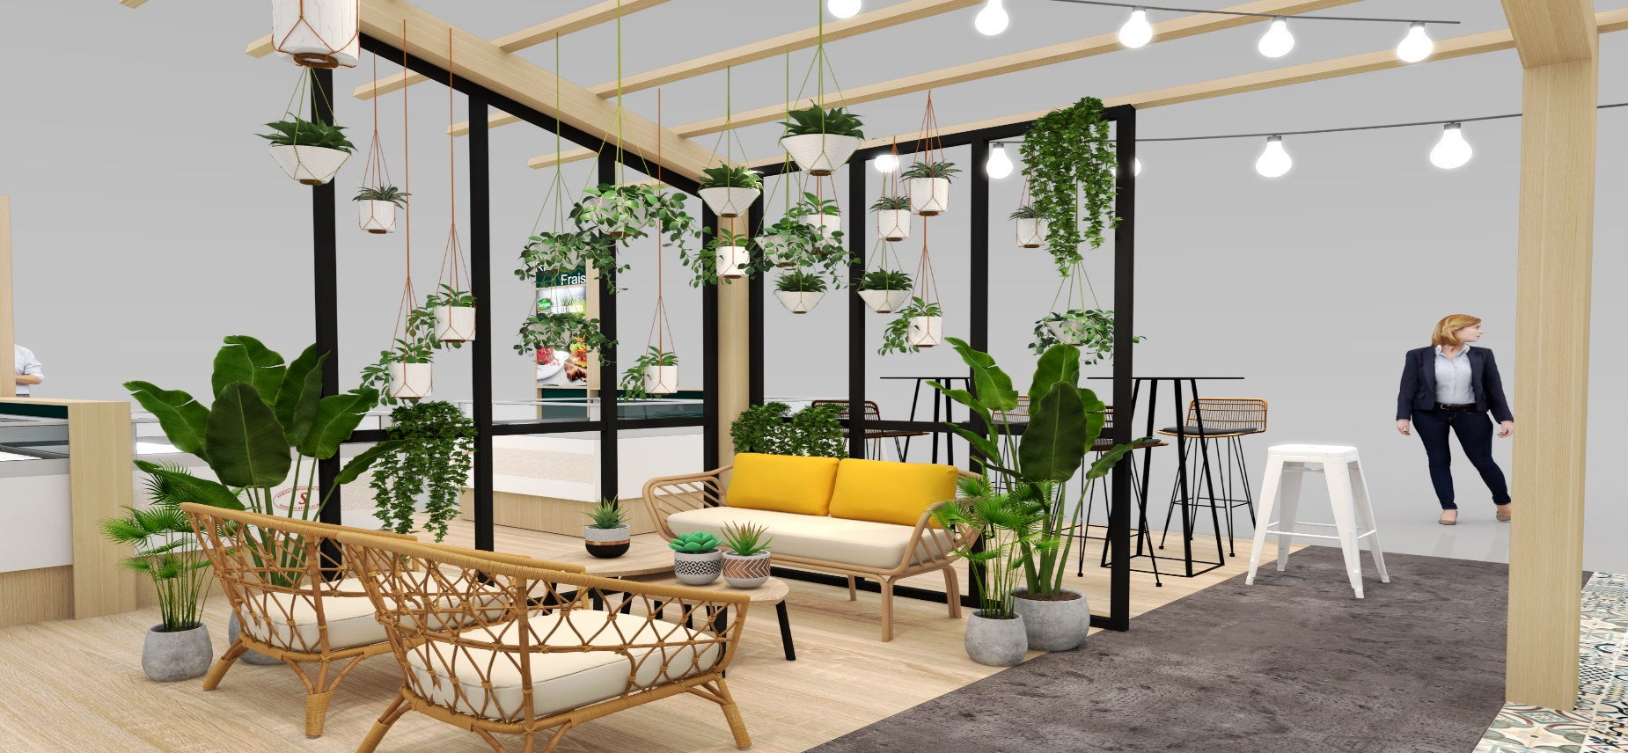

**Our Services**

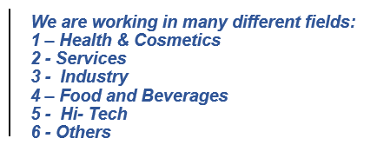



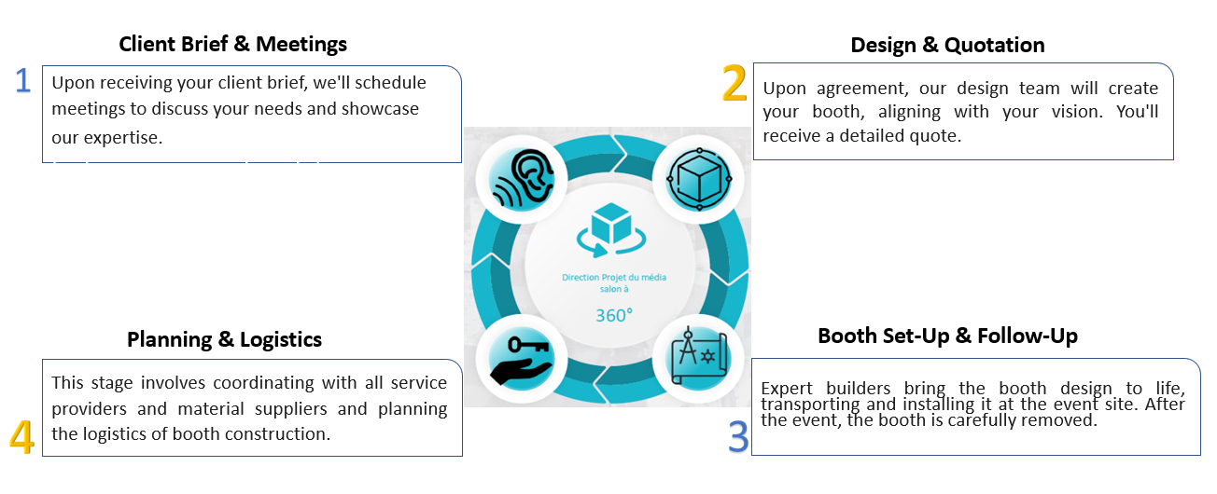

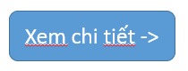

**Custom – Built Booths**

We are experts in creating custom-made booths that meet your specific needs and budget. With years of experience designing and building booths for exhibitions, fairs, and other events. We offer high-quality work that is flexible, durable, and cost-effective. Our team of experts will help you overcome any challenges to ensure the best possible experience at your event.

We offer a wide range of booth sizes to accommodate any event or space:

* Under 50 m2
* From 50 m2 to 150 m2
* 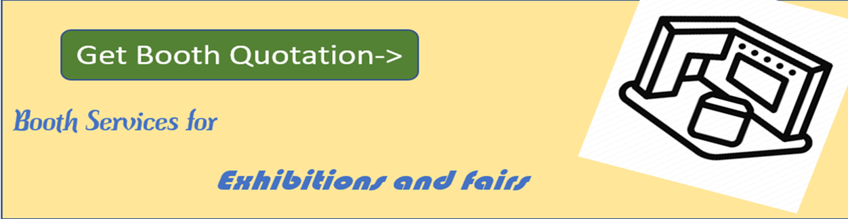Over 50 m2

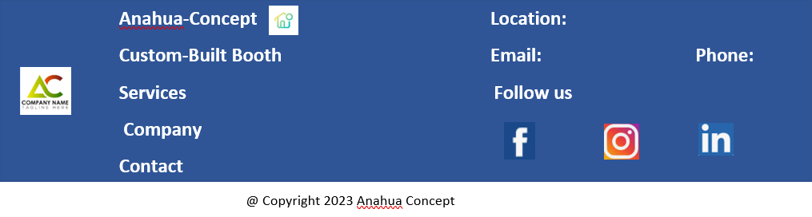

Custom-Built Booths page





* Bullet 1 - Under 50 m2Our specialty is creating custom booths that fit your budget and unique requirements. With years of experience in fairs, exhibitions, and other related events, we provide excellent flexibility, longevity, and cost-effectiveness in our high-quality work. To guarantee the greatest experience in fairs, office buildings, retail settings, and exhibitions, our professionals will assist you in overcoming obstacles. We provide a large selection of booth sizes to meet your unique requirements.

**An under-50 m2 exhibition or fair booth design is a cost-effective way to create an attractive and bright space for your promotional activity. It's perfect for hosting demos, keeping attendees engaged, and making a positive impression on potential customers.**

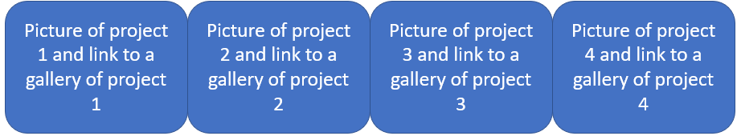

* Bullet 2 - From 50 m2 to 150 m2

Our specialty is creating custom booths that fit your budget and unique requirements. With years of experience in fairs, exhibitions, and other related events, we provide excellent flexibility, longevity, and cost-effectiveness in our high-quality work. To guarantee the greatest experience in fairs, office buildings, retail settings, and exhibitions, our professionals will assist you in overcoming obstacles. We provide a large selection of booth sizes to meet your unique requirements.

**A 50- to 150-m2 exhibition or fair booth design is the perfect size to gain maximum visitor attention and generate leads. With their generous dimensions, these booths can be configured into numerous smaller booths, facilitating the sharing of diverse activities.**

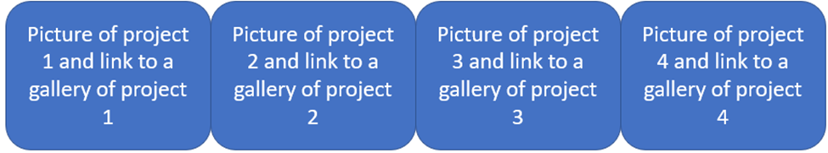

* Bullet 3 - Over 150 m2

Our specialty is creating custom booths that fit your budget and unique requirements. With years of experience in fairs, exhibitions, and other related events, we provide excellent flexibility, longevity, and cost-effectiveness in our high-quality work. To guarantee the greatest experience in fairs, office buildings, retail settings, and exhibitions, our professionals will assist you in overcoming obstacles. We provide a large selection of booth sizes to meet your unique requirements.

**An over 150 m2 exhibition or fair booth provides you with plenty of room and a fantastic chance to hold meetings and demos in an elegant and businesslike manner. This size booth is ideal for large firms, striking displays, and top businesses in their respective fields.**



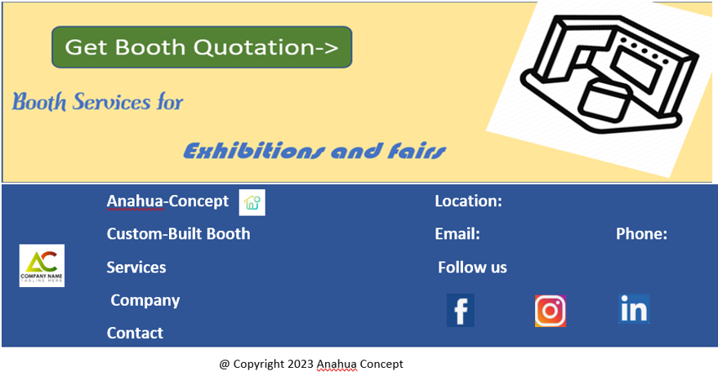

Services page

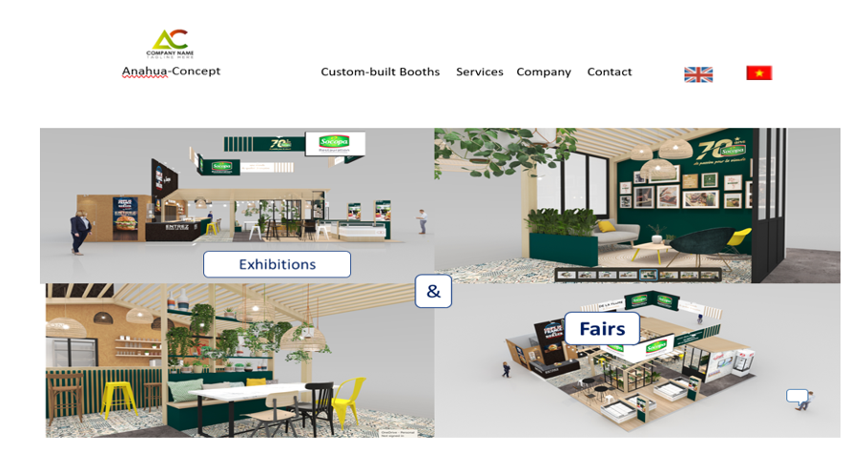



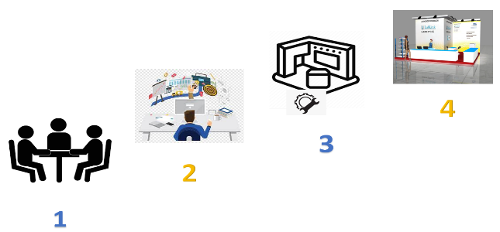With the motto "share, care, dare," we will support you in organizing your events by guiding you through every step of creating your booth. Even the most audacious ideas are achievable. No vision is too grand, no challenge too daunting, when we dare to push the boundaries of what's possible.

1. **Client Brief - Meeting:** Upon receiving your comprehensive client brief, which should include details about your brand identity, objectives, desired booth size, budget, and target delivery date, we will promptly arrange meetings to thoroughly discuss your specific needs and expectations. These meetings will provide us with an opportunity to showcase our designing and manufacturing expertise and capabilities, ensuring that we fully grasp your vision and can deliver an exceptional booth that surpasses your expectations.
2. **Design & Quotation:** Once reaching a mutual understanding and agreements, our team of skilled booth designers and graphic artists will seamlessly transition into action, meticulously crafting a design that flawlessly aligns with your unique vision and aspirations. To ensure complete transparency and clarity throughout the process, we will provide you with a comprehensive quote outlining the project's scope and associated costs at this stage.
3. **Planning & Logistics:** At this crucial stage, our project management team takes the lead, meticulously coordinating with all involved service providers and material suppliers to ensure seamless procurement and delivery of all necessary components. With meticulous planning and attention to detail, we orchestrate the intricate logistics of booth construction, ensuring that every aspect aligns with the approved design and timeline.
4. **Booth Set-up & Follow-up:** With the design finalized and blueprints in hand, the booth construction phase marks the exciting transition from concept to reality. Our team of skilled architects and experienced builders seamlessly collaborate to materialize the booth design, meticulously adhering to the precise specifications and high standards set forth. Once construction is complete, the booth embarks on its journey to the event site, where a team of trained professionals carefully install it, ensuring every element is perfectly in place. Following the event's conclusion, the booth is expertly dismantled and removed from the site, leaving no trace behind. Also, we have storage space available if you need it.

These steps are a general overview of the booth design and construction process, which may vary depending on the client's specific needs and the event.

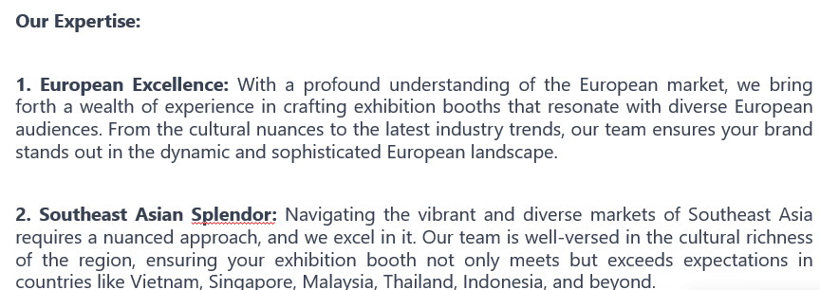



Company page



Since 2005, the founder of Anahua-Concept has honed her skills for an almost 18-year career in booth design for exhibitions and fairs. In 2020, establishing her own office in Ho Chi Minh City, Vietnam, she assembled a team of 5 professionals. Her expertise as a booth designer has led to over 600 projects and collaborations with over 200 clients.

With years of experience in the exhibition booth industry, Anahua-Concept provides comprehensive project management from conception to completion. We even offer convenient storage solutions to keep your booth components safe and secure after your event concludes.

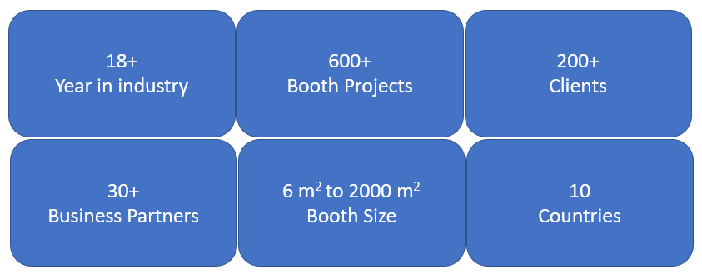



Contact page





